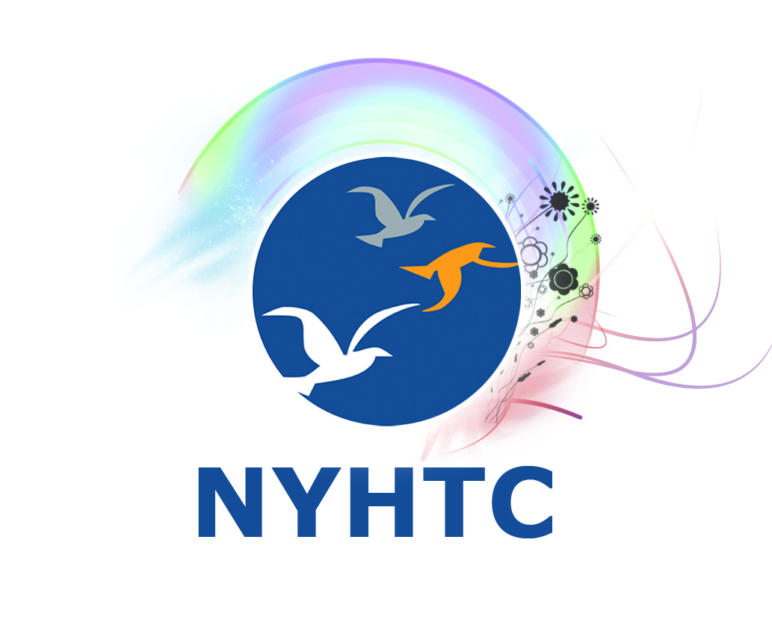
New York Hypnosis Training Center
5000 Expressway Drive South, Holbrook, NY 11741 (631) 737-1510

NLP CERTIFICATION TRAINING ENROLLMENT AGREEMENT

Full Name: ___________________________________________________________

Address: _____________________________________________________________

City: ______________________________ State: ___________ Zip: ____________

Email Address: ________________________________________________________

Home Phone: _______________ Work:_______________ Cell: _________________

SSN (Last Four Digits): xxx-xx_______ Gender: ______ Date of Birth: ___________

Occupation: __________________________________________________________

Indicate course applied for:

Neuro-Linguistic Programing (NLP) Certification (Basic) [ ]

Neuro-Linguistic Programing (NLP) Certification (Master) [ ]

Why are you seeking this training? _________________________________________

_____________________________________________________________________

Describe any related training or experience: _________________________________

_____________________________________________________________________

The above listed school and student, enter into agreement under which the student will pay tuition
and fees as indicated below as will as adhere to the school’s rules and regulations as set forth in the
school catalog. The school will instruct the student in the curriculum listed below in accordance with
Education Law and Commissioner’s Regulations.

PROGRAM | NEURO-LINGUSITIC PROGRAMING (NLP)  BASIC AND MASTER CERTIFICATION COURSES  (Basic and Master courses may be taken and paid for separately)
Hours | Basic: 4 days  Master: 5 days
Registration Fee | $100*
Tuition | Basic: 30 days prior to class start date: $747 After 30 days prior: $797  Master: 30 days prior to class start date: $777 After 30 days prior: $827
Books and Supplies | $200 – Included
Total NLP Basic & Master Course Fee | $1,724 - 30 days prior to class start date  $1,524 - After 30 days prior
Private training is not available for NLP courses.

NLP Certification Class Schedule:

Basic: 4 days - 9:30 am – 5:30 pm Master: 5 days - 9:30 am – 5:30 pm

School Hours of Operation: 9:00 am – 6:00 pm (on days classes are in session)

Start Date: ____________________ Expected Completion Date:________________

Course Payment: NLP Certification Course

Basic Tuition: 30 days prior to class start date: $747 After 30 days prior: $797

Master Tuition: 30 days prior to class start date: $777 After 30 days prior: $827

Registration Fee, Books, Supplies: $300 - included

Tuition may be paid by cash, check, credit card or money order.

*Registration fee is non-refundable and is in accordance with Section 126.7 of the
New York State Education Department Commissioner’s Regulations.

Refund Policy:
A student who cancels within 7 days of signing the enrollment agreement but before instruction
begins receives all monies returned with the exception of the non-refundable registration fee.

Thereafter, a student will be liable for:
- The non-refundable registration fee plus
- The cost of any textbooks or supplies accepted plus
- Tuition liability as of the student’s last date of physical attendance.
- Tuition liability is determined by the percentage of the program offered to the student.

If termination occurs: | School may keep:
0-15% of the program | 0%
16-30% of the program | 25%
31-45% of the program | 50%
46-60% of the program | 75%
After 60% of the program | 100%

The New York Hypnosis Training Center does not offer job placement.

I pledge to use my certification training to better others and/or myself; to conduct myself as a
professional in strict accordance with all existing laws, Code of Ethics and Standards
of Practice.

I agree to the conditions of this agreement. I also verify that I have read and received a copy of
the agreement and the school catalog.

Student Signature_________________________________ Date________________

Please supply any required documentation with this application.

The agent who enrolled me was:

___________________________________ Cert #: ________________________

Student Signature: _______________________________ Date: ______________

The agent who enrolled me was:

__________________________________________Cert #:_________________

Student Signature_________________________________ Date______________

I have received a copy of the Student Disclosure Material.

Student Signature_________________________________ Date______________

Accepted for the school by__________________________ Date ______________

(Entrance Requirement Documentation Received)

